Low-Frequency Signal Decomposition for
Equity Trend Regime Classification
A Causal Decomposition, Feature Engineering, and CNN-GRU Study on SPY

Abstract
This project studies whether a causal decomposition of SPY's price into trend, cycle, and noise components, combined with a broad technical/macro/cross-asset feature set, can classify the market's current trend regime and whether that classification carries any forward-looking value. Four trend-state classes are labeled from the decomposed signal and predicted using a progression of models: a moving-average heuristic, an ADX/DI rule-based baseline, a Random Forest, and a family of CNN and GRU neural sequence models, culminating in a dual-scale CNN-GRU fusion network with regime conditioning. All preprocessing and splits are strictly causal and chronological. The neural models reach test-set accuracies of 0.80–0.86 against a 0.38 majority-class baseline. A dedicated forward-window analysis shows that detected regime changes carry meaningful precision (~71% at a 20-day horizon) but low recall (~18%), and the report is explicit that part of the apparent classification skill is inflated by overlap between the label formula and the feature set. This document favors that kind of transparency over a single flattering headline number.

1. Motivation and Problem Framing
Technical-indicator-based price prediction is one of the most over-claimed applications of machine learning: it is easy to build a model that appears to “predict the market” and very easy for that appearance to be an artifact of look-ahead bias, label leakage, or an unrealistic evaluation protocol. Rather than target next-day or next-week returns — a target with a notoriously low signal-to-noise ratio — this project targets something more tractable and more honestly evaluable: classifying which trend regime the market is currently in, given a causal decomposition of the signal into trend, cycle, and noise. A regime is a description of the present, not a forecast of the future, and this distinction is treated as a first-class design decision throughout, including in how the results are ultimately framed.
A second design goal was to build an evaluation protocol rigorous enough that its own weaknesses could be identified and reported, rather than a protocol optimized to produce an impressive number. Both goals shape every section below.

2. Data and Signal Decomposition
The dataset combines daily OHLCV data for SPY, QQQ, and TLT; price series for XLE, XLF, Gold, and MOVE; daily VIX and 2-year/10-year Treasury yields; and monthly CPI year-over-year, spanning from 2000 through the most recent date in the source data. SPY's closing price is decomposed causally into four components using two exponentially-weighted moving averages: a fast trend (EWM span 20) and a slow trend (EWM span 60). The cycle component is the spread between the two (fast minus slow), and the noise component is the residual between raw price and the fast trend. All EWM calculations use adjust=False, meaning every value at time t is computed only from data up to and including t — there is no use of future information anywhere in the decomposition.
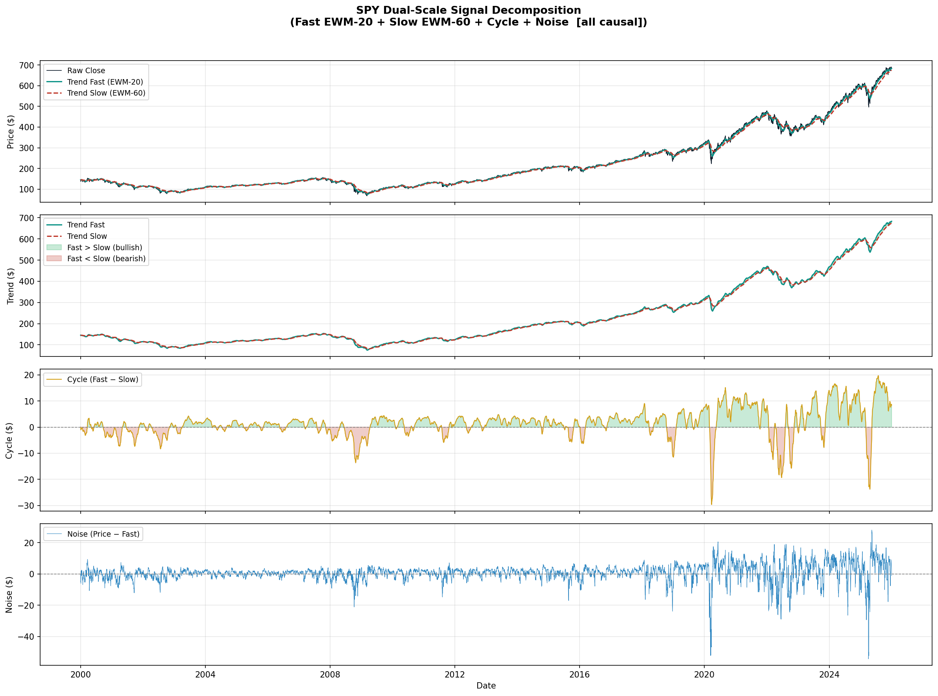
Figure 1. SPY decomposed into fast/slow trend, cycle, and noise (all causal).

3. Feature Engineering
On top of the decomposition, 80 features are constructed (63 base features plus 17 first-difference “delta” versions of the most informative signals, added so the sequence models can see rates of change directly rather than only levels). These fall into six groups:
- Trend decomposition: fast/slow trend slopes and acceleration, fast-vs-slow spread, cycle level/slope/z-score, and price position relative to fast and slow trend.
- Trend strength: ADX-14, DI+/DI− spread, and a 3-way moving-average stack (5/20/50/200-day) alignment score.
- Support/resistance proximity: distance to rolling swing highs/lows, 52-week high/low distance, and Bollinger Band position/width.
- Price momentum: multi-horizon returns and realized volatility (5/10/20/60-day), and RSI-14.
- Cross-asset structure: QQQ/TLT/XLE/XLF returns, SPY–QQQ and SPY–TLT spreads, and a multi-index trend concordance score.
- Macro / risk regime: a VIX/MOVE/TLT-based risk-on/risk-off composite, the 10yr–2yr yield spread, gold, and CPI year-over-year.
Random Forest feature importance confirms that trend-decomposition features — particularly the slow trend slope, cycle level, and fast-vs-slow spread — dominate, followed by MA-stack and momentum features. Macro and cross-asset features contribute comparatively little to this particular label, a useful and somewhat expected finding in itself.

4. Label Construction
Each trading day is assigned to one of four trend states: Trending-Up, Transition-Up, Transition-Down, or Trending-Down. The assignment rule uses the sign of the fast-vs-slow trend spread together with ADX strength (threshold 20) and DI+ vs. DI− direction — for example, Trending-Up requires the fast trend above the slow trend, ADX above 20, and DI+ above DI−, while a fast-above-slow reading without a strong or clearly directional ADX/DI reading is labeled Transition-Up. Raw labels are then smoothed with a 10-day rolling mode to suppress single-day flicker from borderline ADX/DI readings; because the rolling window only looks backward, this smoothing does not introduce any forward-looking information.
This label design is also the project's central limitation, discussed in full in Section 8: several of its inputs (ADX, DI+/DI−, the fast-vs-slow spread) are also present, in the same or a closely related form, in the feature matrix used to predict it.

5. Experimental Design
Evaluation uses a strict chronological 50/25/25 train/validation/test split (3,143 / 1,572 / 1,572 samples for the tabular models; the sequence models lose their first 60 samples per split to the rolling window). The StandardScaler is fit on the training split only and applied unchanged to validation and test. The validation split is used exclusively for early stopping and model selection; the test split is evaluated exactly once, after model selection is finalized, and never used to make design decisions. The ADX+DI rule-based baseline is deliberately lagged by one day, since scoring it on same-day ADX/DI values — the same values used to build the label — would be close to tautological and was found to inflate its accuracy to nearly 1.0 in an earlier version of this pipeline.
The neural models consume two parallel input windows per sample: a 20-day window (for short-horizon inflection patterns) and a 60-day window (for trend structure and regime persistence), with class-weighted cross-entropy loss to counteract label imbalance, Adam optimization (lr=1e-3, weight decay 1e-4) with ReduceLROnPlateau scheduling, gradient clipping, and early stopping on validation macro-F1 with patience of 10 epochs.

6. Models
- MA Stack heuristic — thresholds the 5/20/50/200-day moving-average alignment score directly into the four trend classes.
- ADX+DI rule-based (lagged) — applies the same logical rule used to build the label, but to yesterday's ADX/DI/trend values.
- Random Forest — 300 trees, max depth 10, class-balanced, trained on the full 80-feature tabular matrix.
- CNN-only — a 3-layer 1D convolutional branch over the 60-day window, capturing local trend morphology.
- GRU-only — a 2-layer GRU over the 60-day window, capturing regime persistence and longer dependencies.
- Dual-CNN — concatenates a 20-day short-window CNN branch (inflection detection) with the 60-day CNN branch, no recurrent component.
- CNN-GRU Fusion — the full model: short-window CNN + medium-window CNN + GRU, concatenated with an 8-dimensional embedding of the current ADX regime (weak/moderate/strong), passed through a batch-normalized dense head to a 4-class softmax.

7. Results
Model | Accuracy | F1 (macro)
Naive (majority class) | 0.382 | —
MA Stack heuristic | 0.609 | 0.524
ADX+DI rule-based (t-1 lag) | 0.776 | 0.744
Random Forest (300 trees) | 0.875 | 0.871
CNN-only | 0.800 | 0.762
GRU-only | 0.858 | 0.858
Dual-CNN (no GRU) | 0.810 | 0.775
CNN-GRU Fusion (full model) | 0.820 | 0.770

All neural and tree-based models comfortably beat the 0.382 naive (majority-class) baseline, and the ADX+DI and Random Forest baselines beat the MA-stack heuristic, as expected given their access to more explicit trend-strength signal. Two results stand out. First, Random Forest's 0.875 accuracy is the highest of any model — but, as discussed in Section 8, this is also the model most directly exposed to the label-feature overlap and should not be read as the strongest genuine result. Second, among the neural sequence models, the simplest one — GRU-only — outperforms the full CNN-GRU fusion architecture on both accuracy and F1, despite the fusion model having access to strictly more information (both CNN branches, plus regime conditioning).
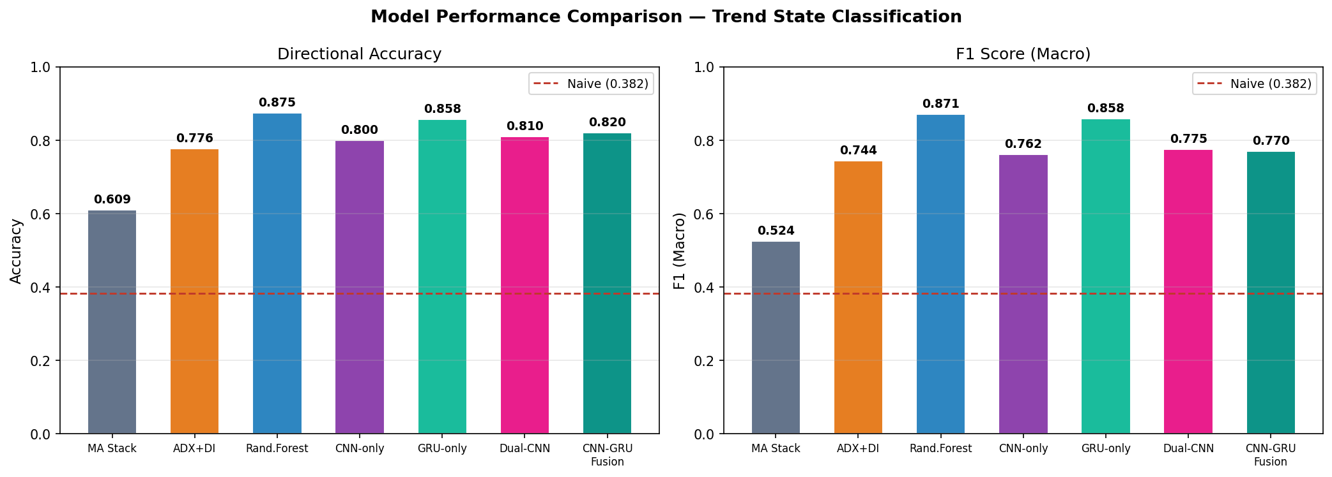
Figure 2. Directional accuracy and macro-F1 across all seven models, with the naive baseline for reference.

8. Limitations and Honest Interpretation
Label–feature overlap. The most important caveat in this project: the trend-state label is constructed directly from ADX, DI+/DI−, and the fast-vs-slow trend spread, and closely related versions of these same quantities (adx_14, di_diff, trend_fast_vs_slow, trend_cross_signal) are also feature columns. This means the Random Forest and, to a lesser extent, the ADX+DI baseline are partly recovering the label's own construction formula from its ingredients rather than learning a generalizable pattern from data the label wasn't built from. Their accuracy numbers should be read as an upper bound on how separable the label is given its own inputs, not as evidence of predictive skill. The neural sequence models are a fairer comparison point, since they consume 60-day rolling windows of the full feature set and must learn temporal dynamics rather than reading instantaneous label ingredients — though they are not fully immune to the same issue.
Fusion underperforms GRU-only. Adding CNN branches and regime conditioning to the GRU increased model complexity without improving held-out performance. Plausible causes include limited effective training data (roughly 3,000 sequences after windowing) relative to the added parameter count, and that regime persistence — the thing a GRU is specifically built to capture — matters more for this label definition than the local windowed shape information the CNN branches are designed to extract. This is reported as a genuine, unresolved finding rather than tuned away.
Weak forward-looking recall. The forward-window analysis below shows that when the model does flag an impending regime change at a 20-day horizon, it is correct roughly 71% of the time on the blind test set — but it only catches about 18% of the changes that actually occur. In practice this means the system is better read as a moderately reliable confirming signal than as an early-warning system, and that gap is exactly the kind of result that a forecasting claim would need to grapple with directly rather than omit.
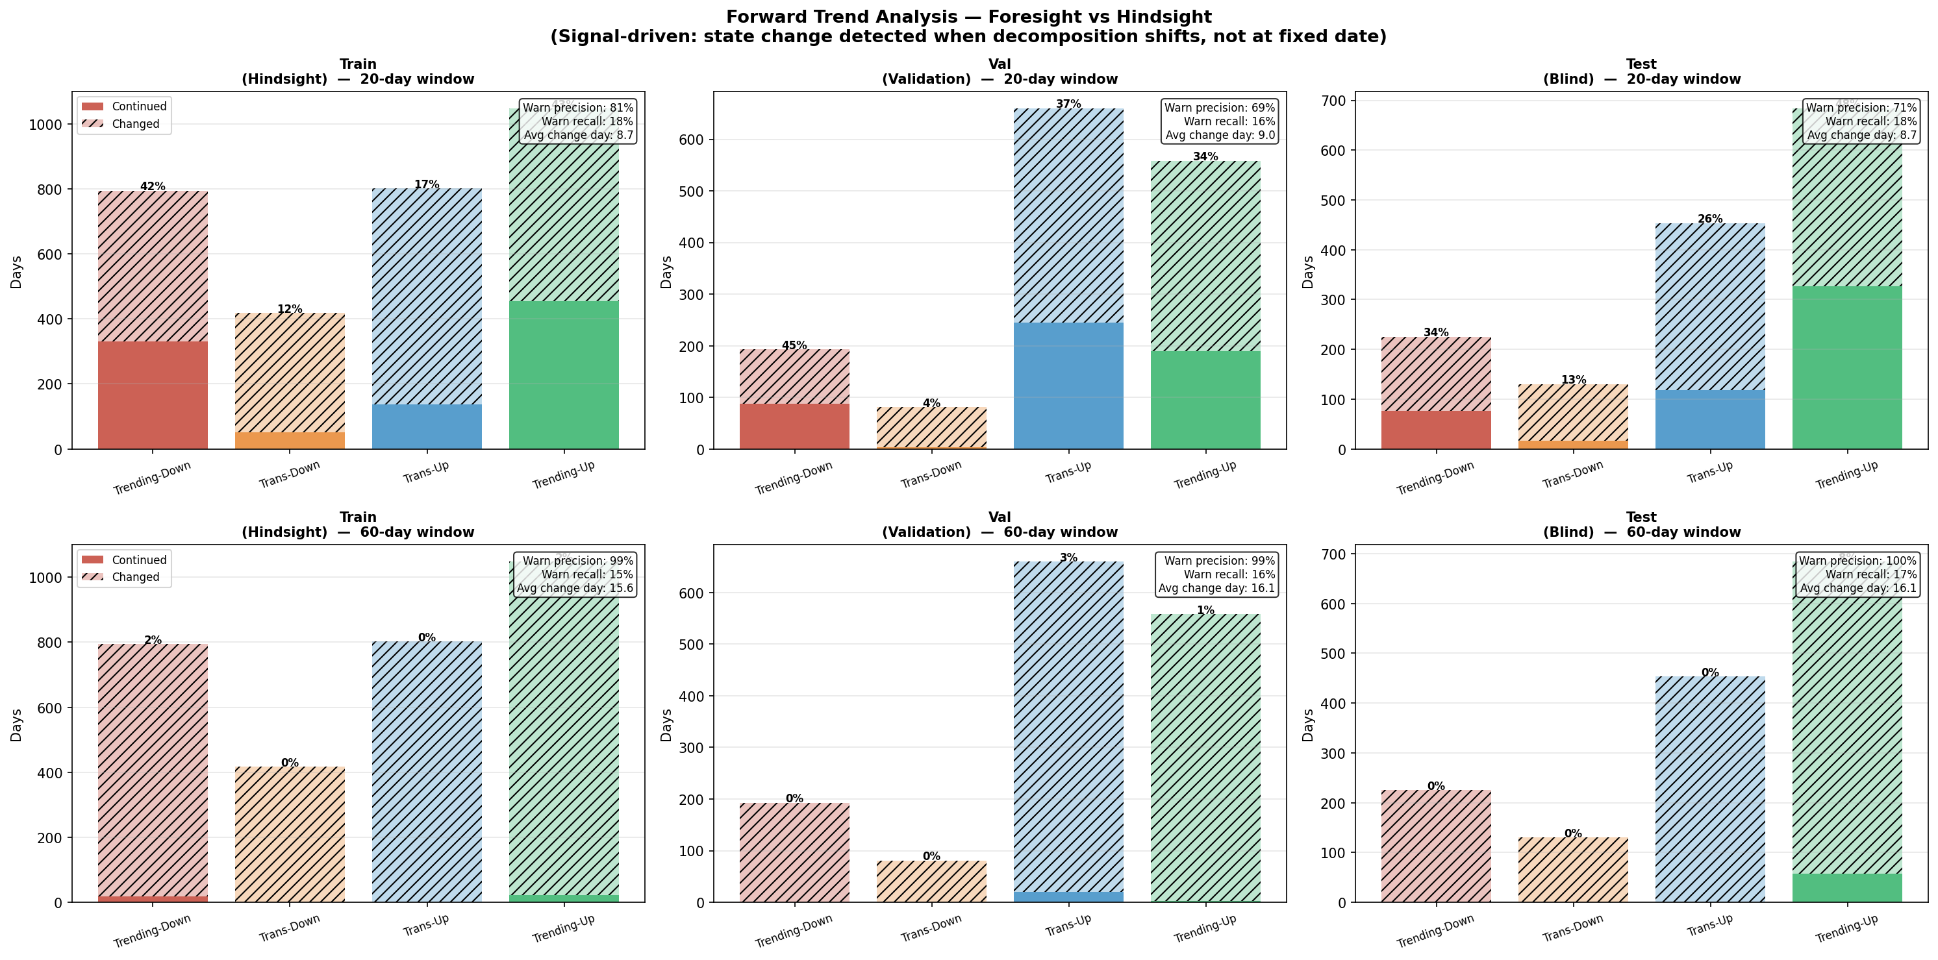
Figure 3. Forward trend analysis — continuation vs. change rate and warning precision/recall, at 20-day and 60-day horizons, across train/validation/test.
Single chronological split. Results come from one 50/25/25 split rather than a walk-forward or expanding-window backtest across multiple market regimes (e.g., the 2008 and 2020 drawdowns fall in different partitions of the data across the three splits), so the reported metrics carry more sampling variance than a multi-fold evaluation would.

9. Future Work
- Fully decouple label construction from feature construction — e.g., label using realized forward Sharpe ratio or a volatility-adjusted return threshold over a forward window, retaining ADX/DI/MA-stack purely as predictive features with no shared formula.
- Ablate the fusion architecture's components (regime embedding, short-CNN branch) individually against a fixed training budget to isolate why it underperforms GRU-only.
- Replace the single chronological split with a walk-forward or expanding-window backtest spanning multiple market regimes.
- Extend the forward-window analysis into a simple rule-based position-sizing or risk-flagging overlay, to test whether the ~71% warning precision translates into a usable, if modest, practical signal.

10. Conclusion
This project demonstrates a complete, causally-correct pipeline from raw price decomposition through feature engineering, label design, and a progression of baseline-to-neural models, evaluated under a chronological protocol that avoids the most common pitfalls in financial machine learning (lookahead bias, test-set leakage into scaling or model selection). Its neural sequence models achieve a meaningful, non-trivial improvement over a naive baseline and over simple rule-based heuristics. Just as importantly, the project explicitly identifies where its own strongest-looking result (Random Forest accuracy) is inflated by label-feature overlap, reports a counter-intuitive architecture result (GRU-only beating the full fusion model) instead of hiding it, and quantifies its forward-looking value honestly rather than only reporting hindsight classification accuracy. That combination — technically sound methodology paired with a clear-eyed account of its own limitations — is the intended contribution of this work.

